

MEHRAN UNIVERSITY OF ENGINEERING
AND TECHNOLOGY, JAMSHORO

DEPARTMENT BIOMEDICAL ENGINEERING DEPARTMENT

Subject: DSIP AND CONTROL SYSTEM
Batch-22ES

DSIP Based Line Following Robot System

Name: DANIYAL 22ES077

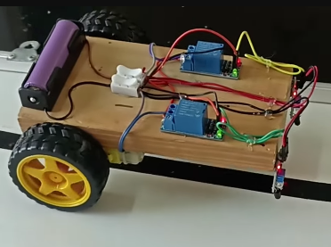

Introduction

A line follower robot is an autonomous robotic system designed to move along a predefined path by detecting the contrast between two surfaces, typically a black line on a white background. Such robots are widely used in industrial automation, transportation systems, and robotics research.
In this project, a line follower robot is implemented without using any microcontroller, relying completely on analog and digital hardware components. This makes the system simple, cost-effective, and highly efficient in terms of real-time response.
The main focus of this project is to demonstrate the integration of Control Systems and Digital Signal and Image Processing (DSIP) concepts. The robot continuously senses its environment using infrared sensors and adjusts its motion using a feedback-based control mechanism.
From a control system viewpoint, the robot behaves as a closed-loop system, where sensor feedback is used to minimize error and maintain alignment with the path. From a DSIP perspective, the system performs basic operations such as signal acquisition, thresholding, and binary classification, which are fundamental steps in image processing.
This project provides a strong foundation for understanding how intelligent behavior can be achieved using simple electronic circuits.

Objectives

The main objectives of this project are:
- To design and construct a line follower robot using only hardware components
- To eliminate the use of microcontrollers and software programming
- To implement a closed-loop feedback control system
- To understand the working of IR sensors in surface detection
- To perform analog-to-digital signal conversion using comparators
- To apply logic gate circuits for decision-making
- To demonstrate real-time system response
- To analyze system performance under different conditions

Related Theory

Control Systems

A control system is a system that manages and regulates the behavior of another system using feedback. It consists of three main parts: input, processing, and output.
In this project:
- Input: Line position
- Sensor: IR sensors detect line
- Controller: Comparator + logic gates
- Output: Motor movement
The system uses a closed-loop control mechanism, meaning the output continuously depends on feedback from sensors.
Types of Control Applied
- ON-OFF Control:
The system switches between states (left, right, forward) based on sensor input.
- Feedback Control:
The robot continuously corrects its path using sensor feedback.

Digital Signal and Image Processing

Digital Signal Processing involves analyzing signals to extract meaningful information.
In this project, the following DSIP steps are applied:
1. Signal Acquisition
IR sensors emit infrared light and detect reflected signals from the surface.
2. Signal Conditioning
The reflected light generates an analog voltage signal.
3. Thresholding
A comparator (LM393) compares the signal with a reference voltage.
4. Digitization
Output becomes binary (0 or 1).
5. Decision Making
Logic gates process binary signals to determine motion.
👉 This is similar to binary image processing, where:
- Black = 0
- White = 1
Thus, the robot performs basic line detection, which is a simplified form of image processing.

System Overview
The system is designed using infrared sensors, relay modules, and DC geared motors to create a line follower robot without a microcontroller. The IR sensors detect the path, and relay modules act as switching elements to control motor direction.
The overall system consists of sensing, signal processing, and actuation stages. The sensors detect the line, and based on their output, the relays switch the motors ON or OFF to guide the robot along the path.

Components Required

Battery (3.7V) and Holder
A 3.7V rechargeable battery is used to power the entire system. The battery holder ensures proper connection and stability.
IR Sensors (2)
Two infrared sensors are used to detect the line. These sensors differentiate between black and white surfaces based on reflected infrared light.
Relay Modules (2)
Relay modules are used as switching devices. They control the motors by turning them ON or OFF based on sensor signals. Each relay is connected to one motor.
Geared Motors and Wheels
DC geared motors provide controlled movement and sufficient torque for the robot. Wheels are attached to enable smooth motion.
Switch
A switch is used to turn the system ON and OFF easily
Chassis
Holds all components together.

Working Principle

The robot follows a line using two IR sensors placed at the front. These sensors continuously detect the surface:
- White surface → reflects IR light → sensor outputs HIGH
- Black line → absorbs IR light → sensor outputs LOW
Each sensor is connected to a relay module. The relay acts as an electronic switch that controls the motor.
Operation:
- When both sensors detect white surface → both motors run → robot moves forward
- When left sensor detects black line → left motor stops → robot turns left
- When right sensor detects black line → right motor stops → robot turns right
- When both sensors detect black → robot stops
This creates a feedback control system, where sensor input directly controls motor output.

Circuit Diagram

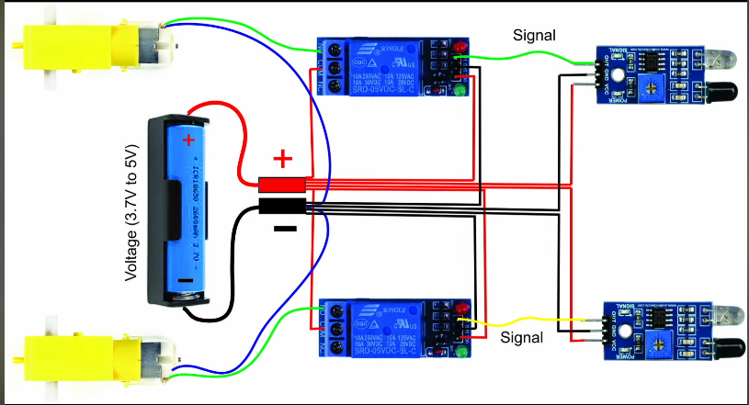

- Each IR sensor is connected to a relay module input
- Relay outputs are connected to motors
- Battery supplies power to relays and motors
- Switch controls power flow
The relay acts as a controller, switching motors based on sensor signals.

Implementation / Methodology

The robot is implemented using a hardware-based approach without any microcontroller. First, the chassis is assembled and DC geared motors with wheels are mounted for movement. A 3.7V battery with holder is used as the main power supply, and a switch is added for ON/OFF control.
Two IR sensors are fixed at the front of the robot to detect the black line based on infrared reflection. These sensors are connected to two relay modules, which act as switching devices. Each relay controls one motor, enabling movement decisions based on sensor input.
When the IR sensor detects a white surface, the relay activates the motor, and when it detects a black line, it changes or stops motor operation. This creates a simple hardware-based feedback system.
Finally, the system is tested on a track, and sensor position is adjusted for proper line detection and stable movement.

Results and Observations

The line follower robot was successfully tested on a black line over a white surface. The system responded to IR sensor inputs and controlled the motors through relay modules without the use of a microcontroller.
During testing, the robot was able to follow straight paths smoothly and adjust its direction when deviation from the line occurred. When the left or right sensor detected the black line, the corresponding relay switched the motor to correct the movement.
It was observed that the robot performed best on well-defined and high-contrast lines. Slight delays in response were noticed due to the mechanical switching time of relay modules. Sensor height and alignment had a direct impact on accuracy and stability.
Overall, the system demonstrated reliable basic line-following behavior using a simple hardware-based control approach.

Advantages

The line follower robot designed without a microcontroller offers several benefits due to its simple hardware-based structure.
- The system is low cost as it uses basic electronic components like IR sensors and relay modules.
- It does not require programming, making it easy to design and implement.
- The circuit is simple and easy to understand, especially for beginners in electronics and robotics.
- It provides real-time response because decisions are made directly through hardware.
- It helps in understanding fundamental concepts of control systems and digital signal processing practically.
- Troubleshooting is easier since the system is purely hardware-based.

Limitations

Despite its simplicity, the system has some limitations:
- Relay switching is slow compared to electronic switching methods, causing slight delays in response.
- The robot cannot handle complex paths or intersections efficiently.
- There is no speed control mechanism for motors.
- Accuracy depends heavily on proper sensor alignment and surface conditions.
- The system lacks flexibility and cannot be modified easily for advanced functions.
- Mechanical wear and tear may occur in relay modules over time.

Applications
This type of line follower robot can be used in several basic and industrial applications:
- Automated Guided Vehicles (AGVs) in factories
- Material transportation in warehouses
- Educational robotics projects for students
- Simple navigation systems in controlled environments
- Demonstration of control system concepts in labs
- Basic automation systems in industries

